
SECTION 1

1. INTRODUCTION

1.1 Scope

1.1.1 This manual deals with the structural design parameters of shear wall system utilizing the Sterling PLASWALL permanent formwork.

1.1.2 For the purpose of this manual, reinforced concrete shear wall structures are the main emphasis conforming to ACI 318M:2005, BS 3110-1:1997, NSCP 2001, IS 456:2000, and IS 13920:1993.

1.1.3 Load analysis of the whole structure must conform to the recognized national Structural code & standards of the country where the project is to be constructed.

2. REFERENCES

2.1 Load Analysis:

2.1.1 Philippine / SE Asia / Pacific Region

NSCP 2001 - National Structural Code of the Philippines
UBC 1997 - Uniform Building Code

2.1.2 Middle East / British Territories

BS 6399 - Loadings for Buildings
IBC 2003 - Seismic Analysis

2.2 Post analysis – Concrete Design

2.2.1 Philippine / SE Asia / Pacific Region

NSCP 2001 - National Structural Code of the Philippines
ACI 318M 2005- American Concrete Institute Code
2.2.2 Middle East / British Territories

BS 8110-1:1997 - British Standard Concrete Code.

3. PRODUCT DESCRIPTION

3.1 PLASWALL Panel

3.1.1 Is a pre-manufactured panel basically a permanent shear wall formwork with punched plastic spacers between two fiber cement sheets.

3.1.2 If needed, additional load capacity can be obtained by providing additional reinforcing bars and/or increasing the grade of the concrete as per discretion of the Structural Design Engineer.

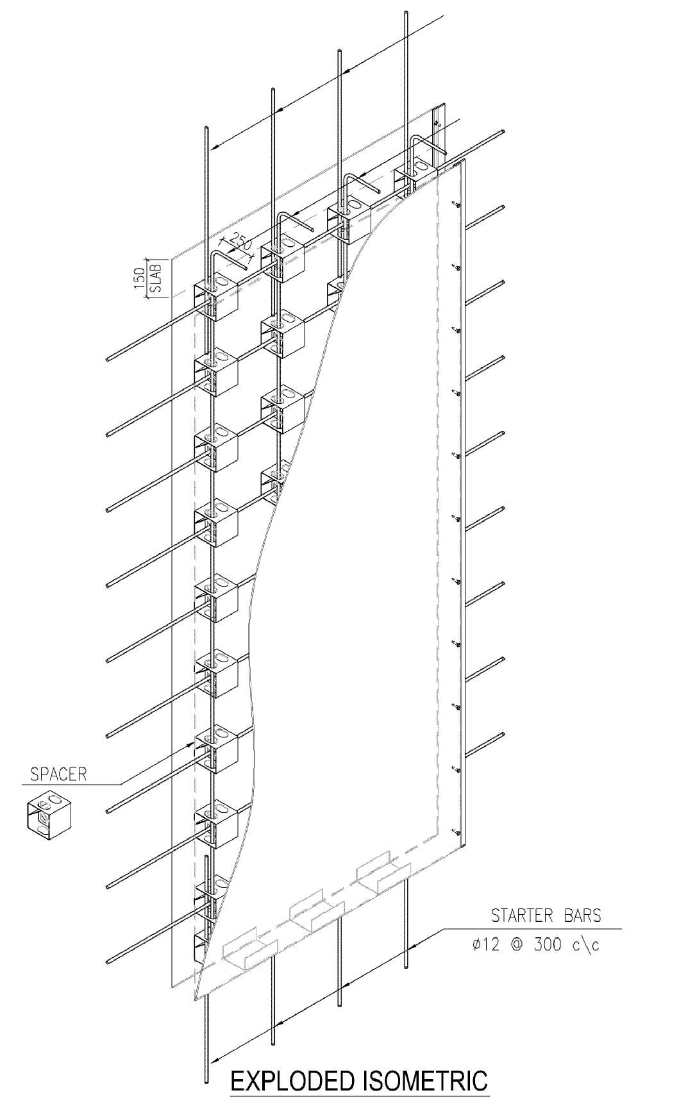

  - Panel Dimension:

3.2.1 Commercial Thickness

109mm 159mm
112mm 162mm
134mm 209mm
137mm 212mm

3.2.2 Standard Height

2440mm to 3660mm – Be sure to verify desired PLASWALL height as per respective country location of the project.

3.3 Structural Concrete Fill

As per Structural Design specification and/or as per project site governing Structural Code but minimum of 20Mpa and maximum of 30 MPa compressive strength.

3.4 Reinforcement

3.4.1 Deformed bar Yielding Strength (fy):

3.4.1.1 Philippines / SE Asia / Pacific Region

Grade 33 - 227Mpa
Grade 40 - 276Mpa
Grade 60 - 413Mpa

3.4.1.2 Middle East / British Territories

Fe415 Mpa
Fe460 Mpa
Fe500 Mpa
Fe550 Mpa

3.4.2 Maximum Size & spacing

Global parameter
Max. size : 8 x thickness
Minimum size : 10mm
Maximum Spacing : 3 x thickness
<= 450mm
Steel Ratio : 0.0025 – 0.01

4. AXIAL LOAD CAPACITY

4.1 NSCP 2001 Parameter:
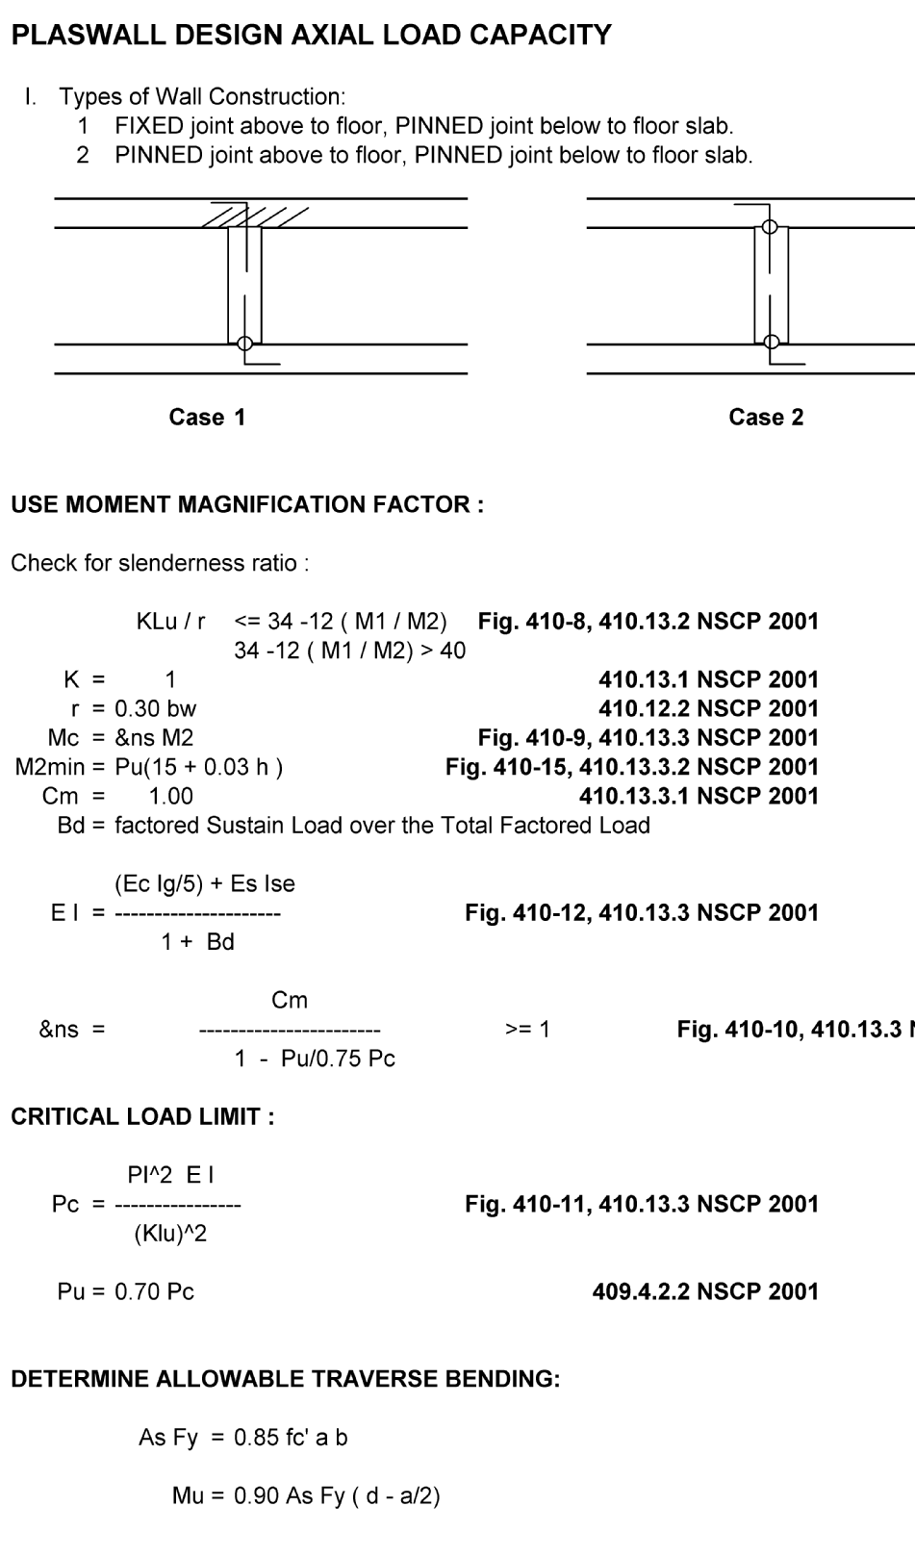

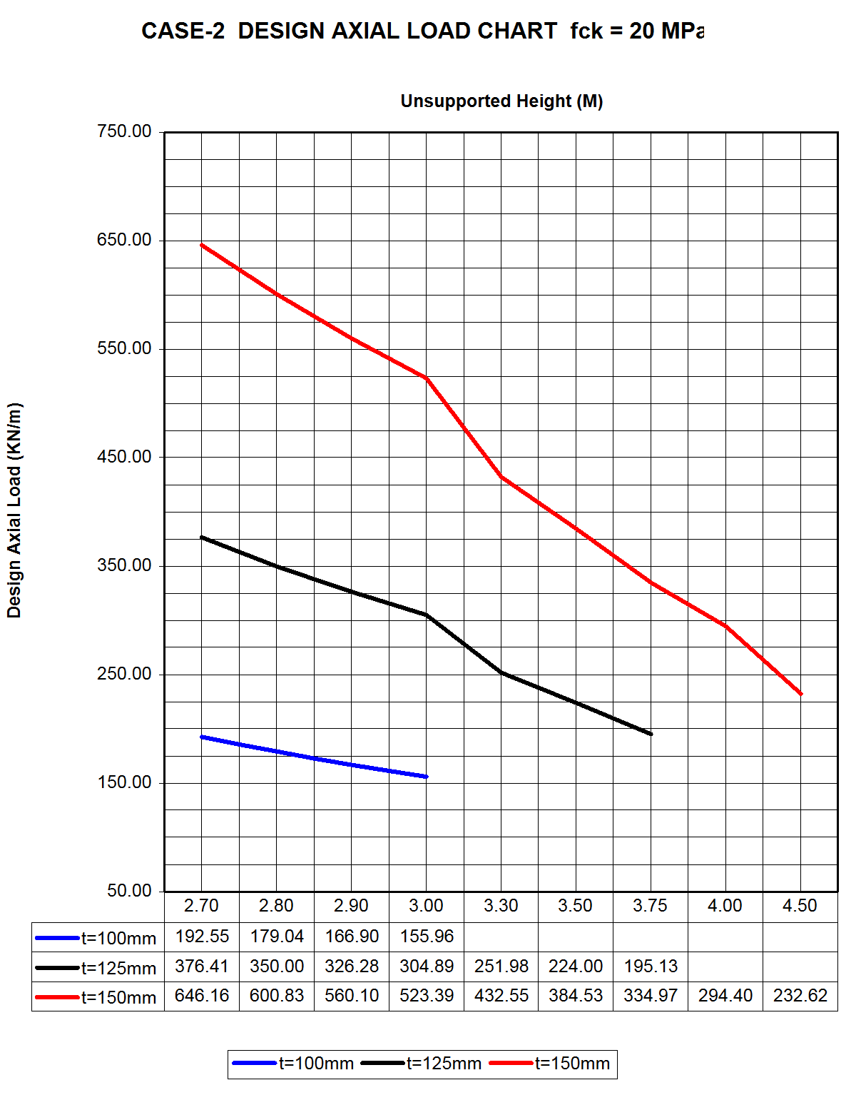

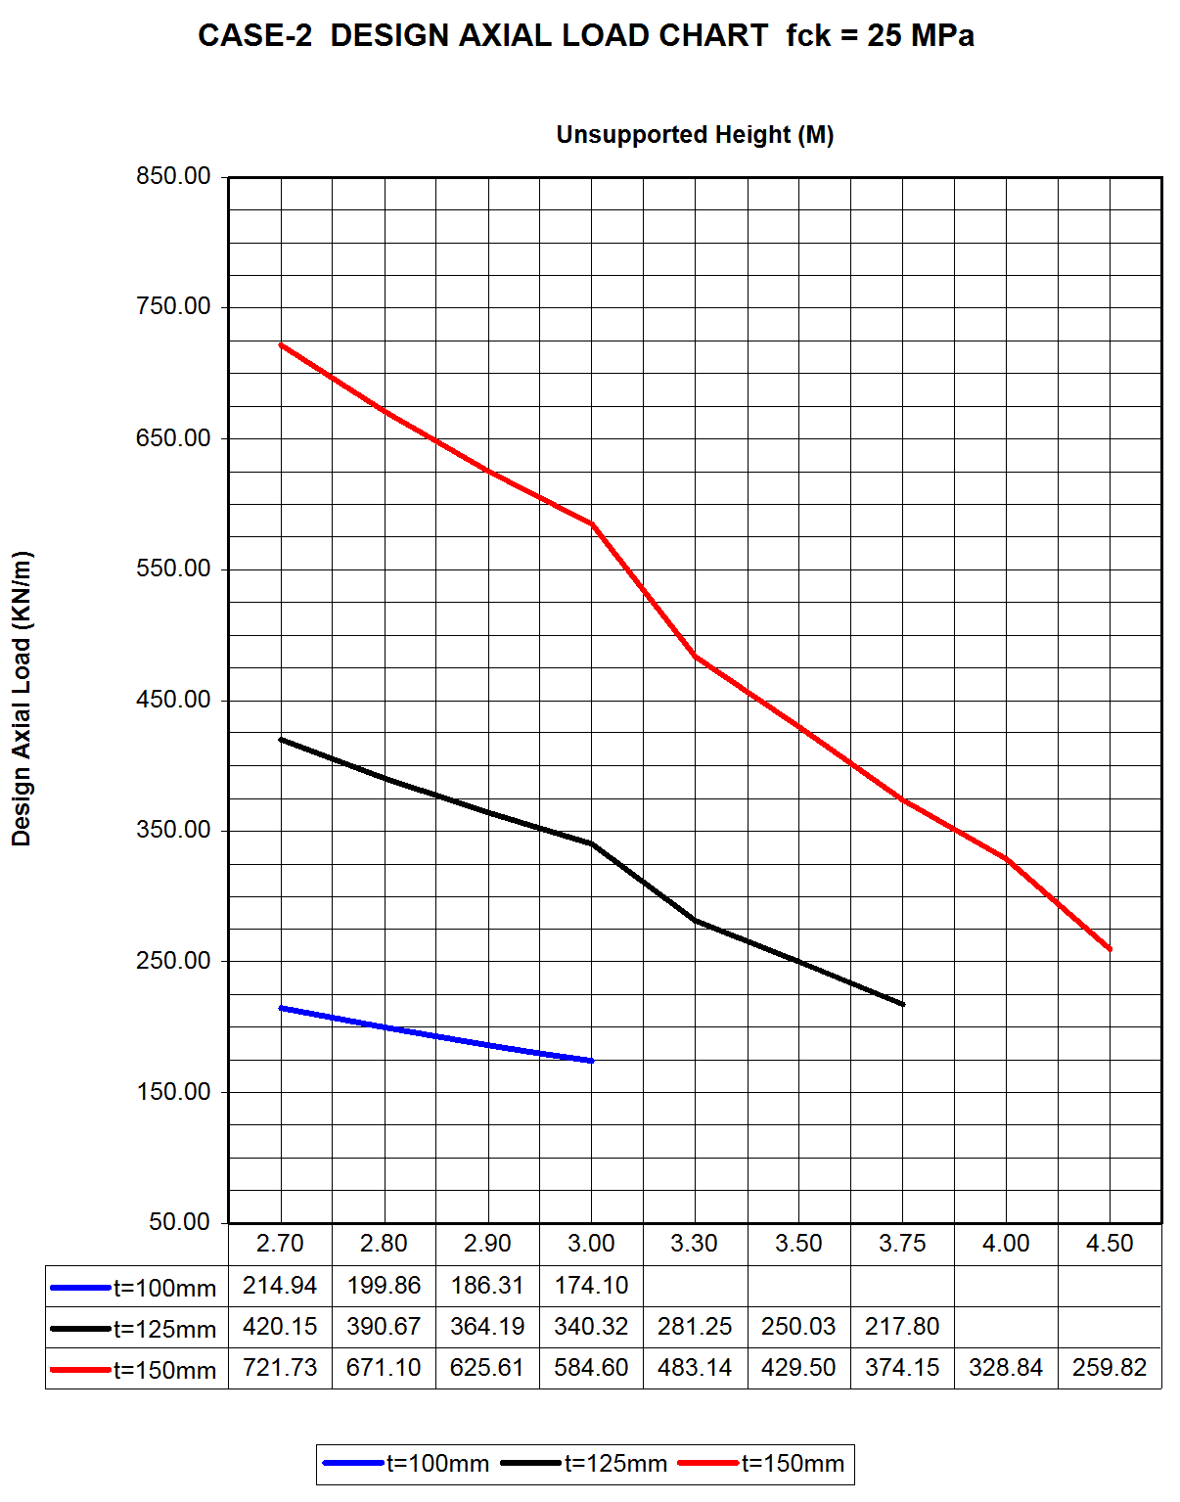

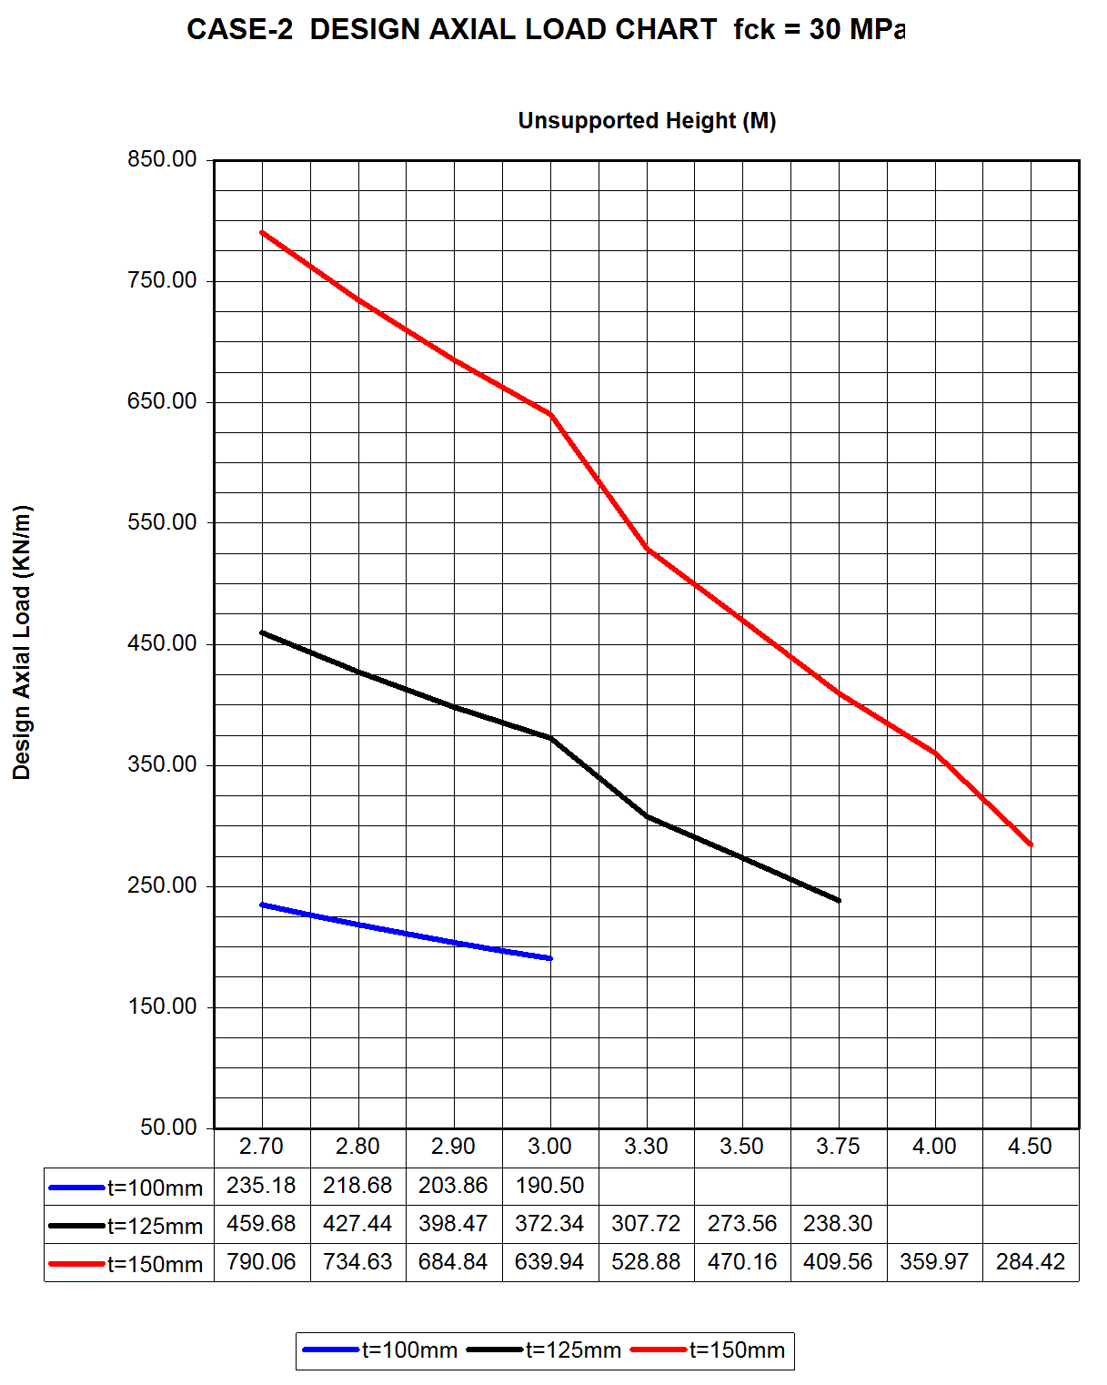

4.2 ACI 318M 2005 Parameter
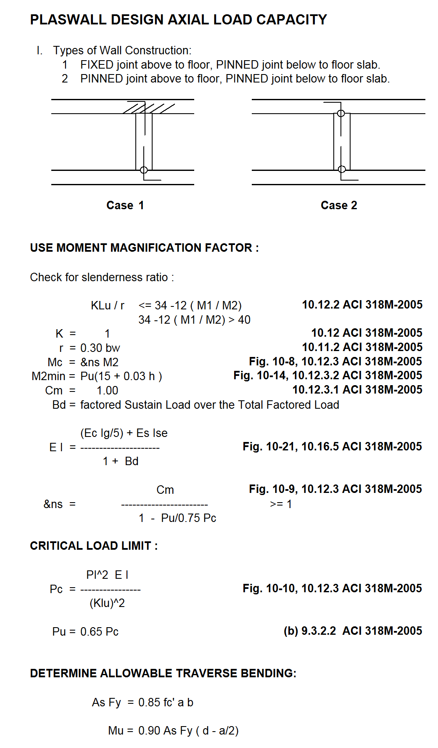

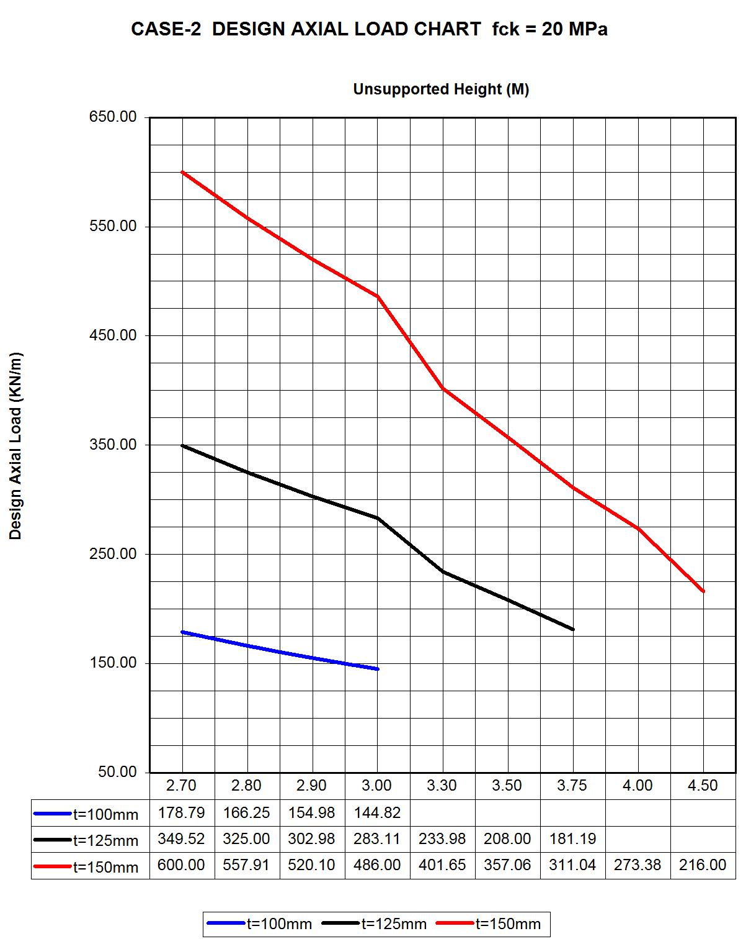

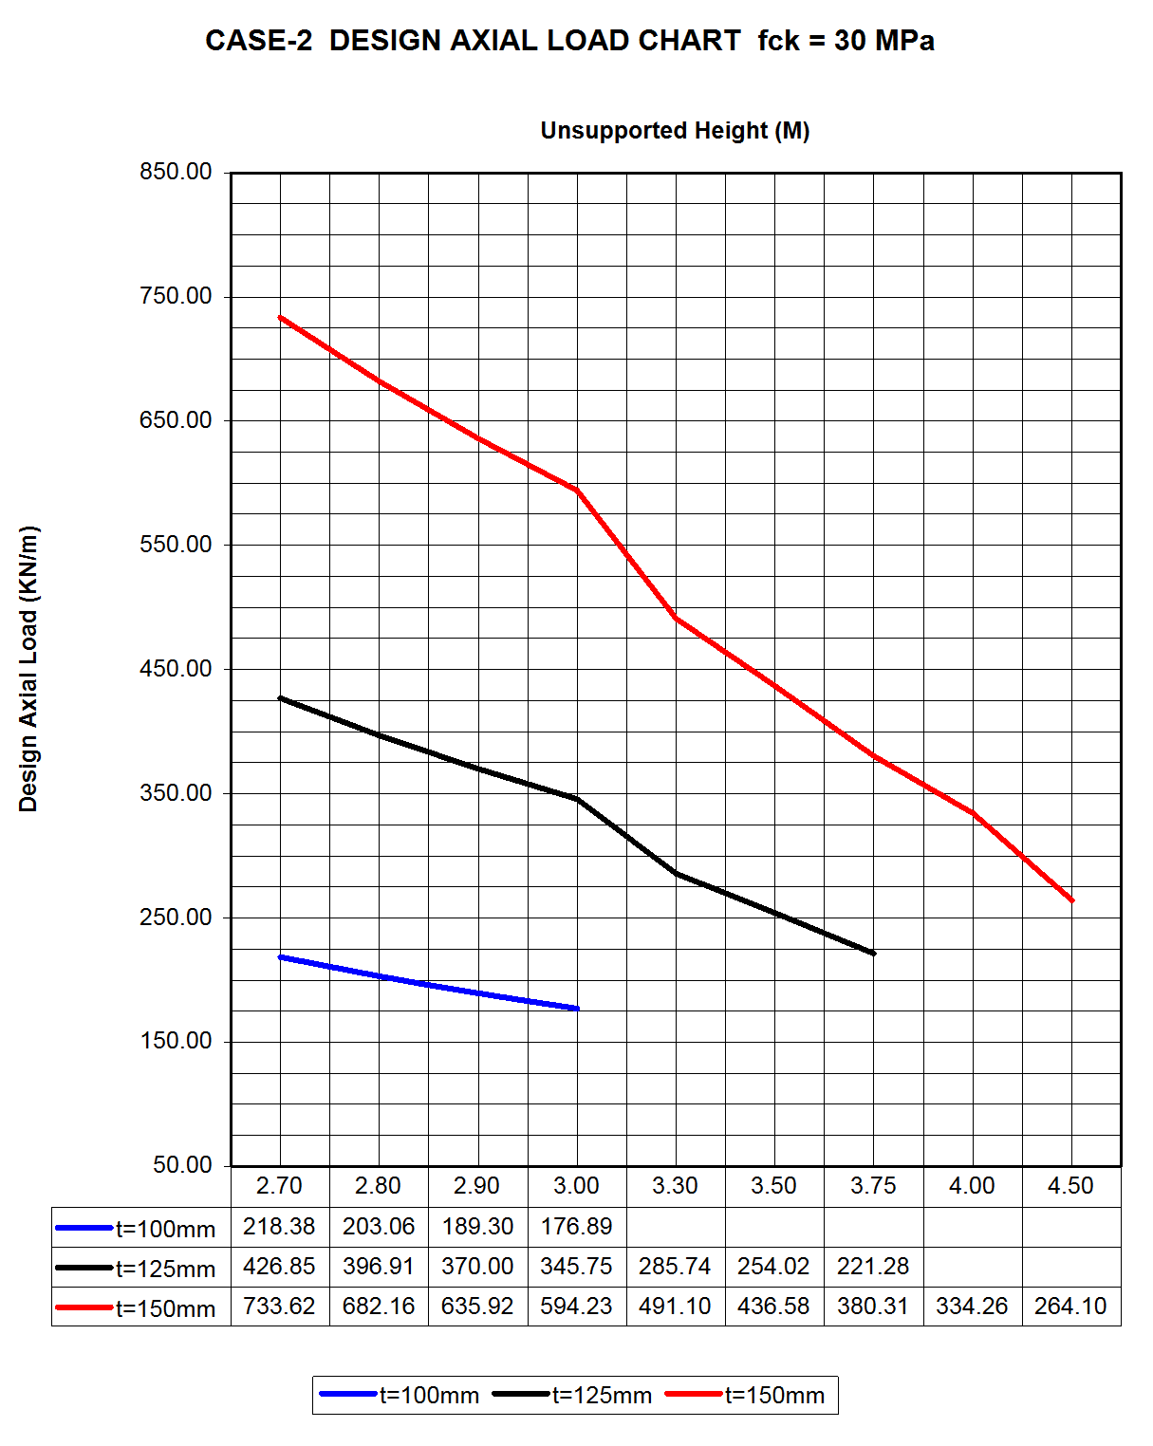

4.3 BS 8110-2:2005 Parameter

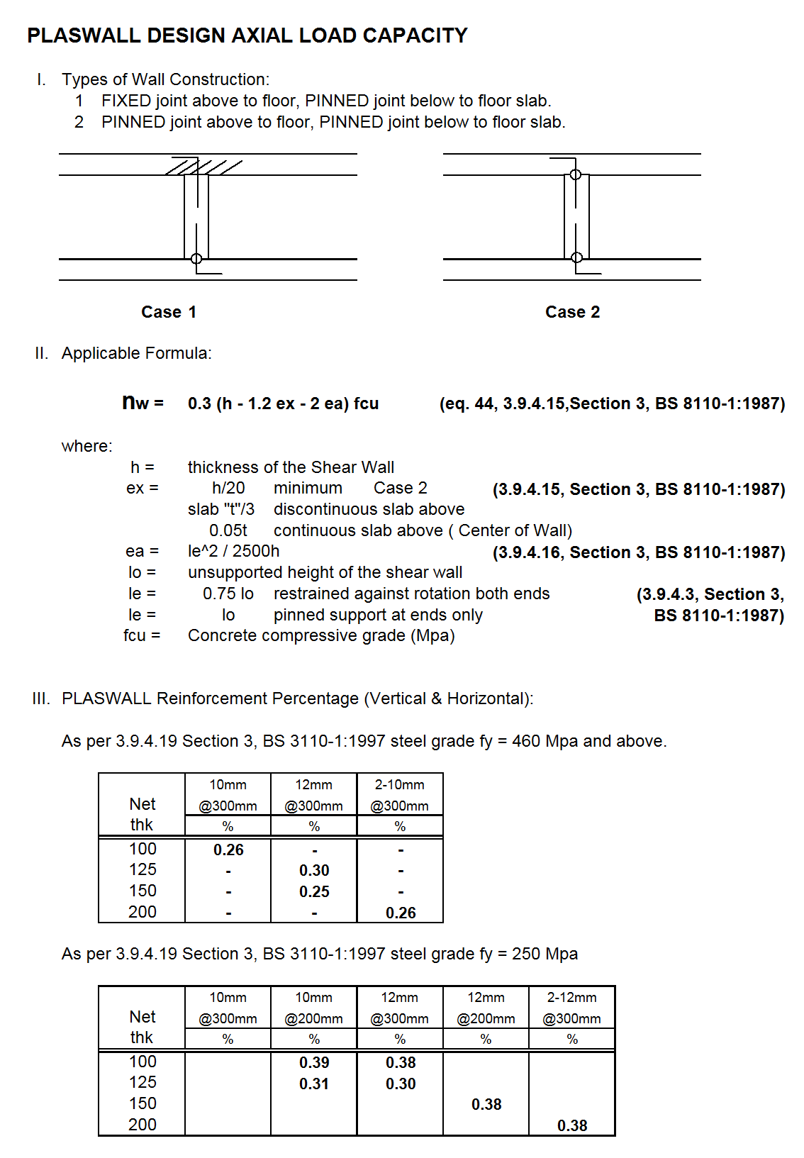

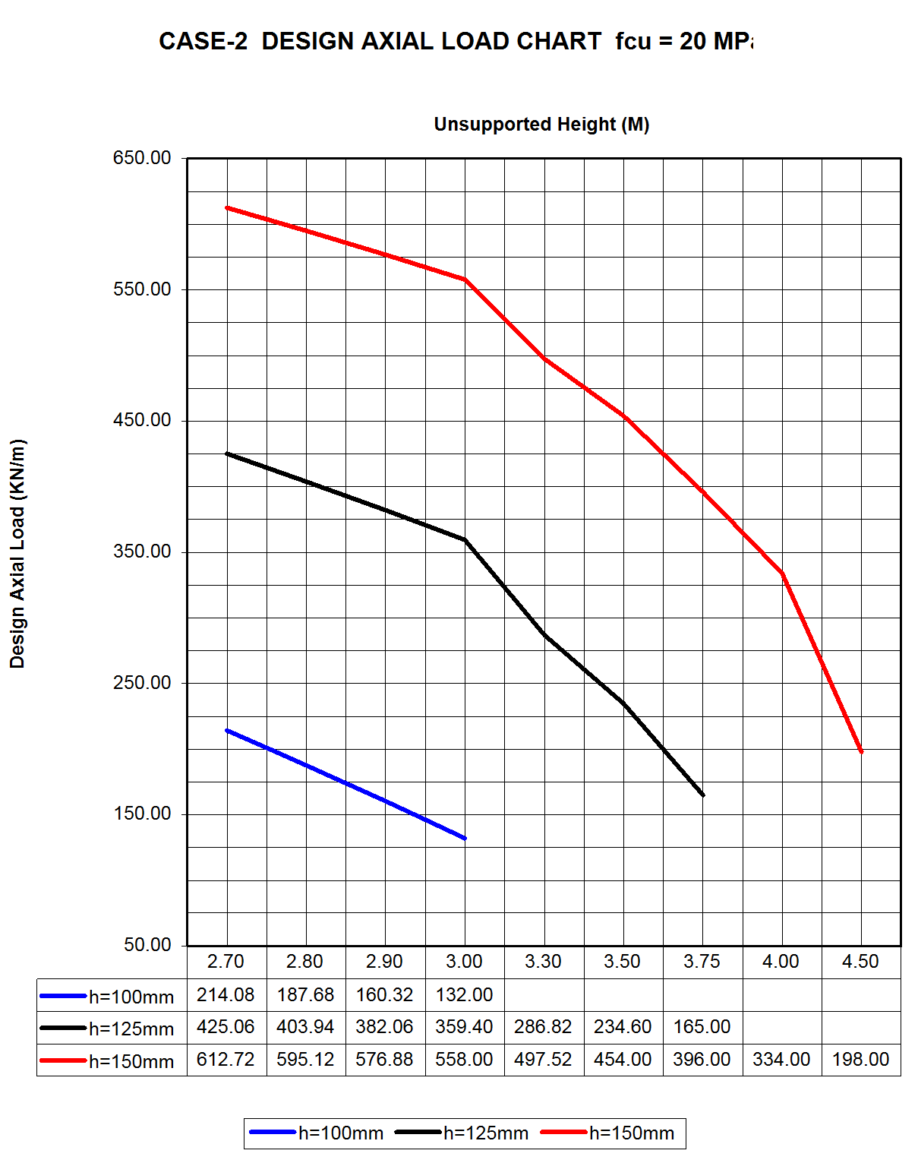

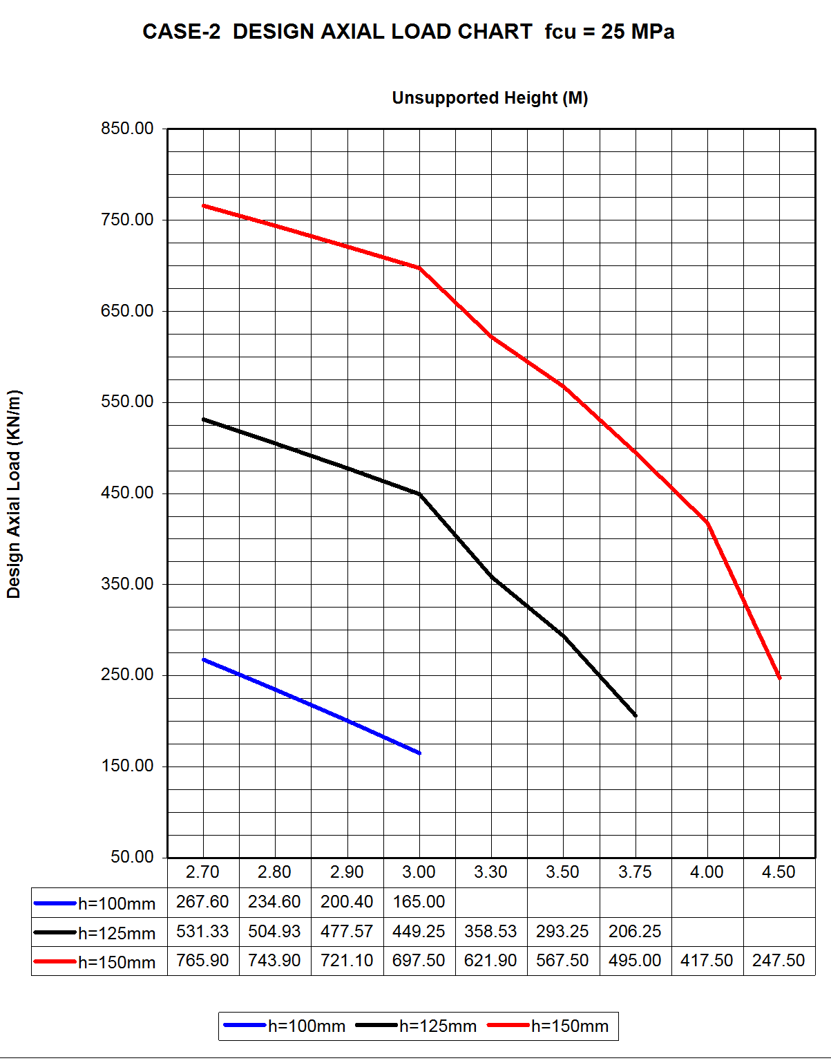

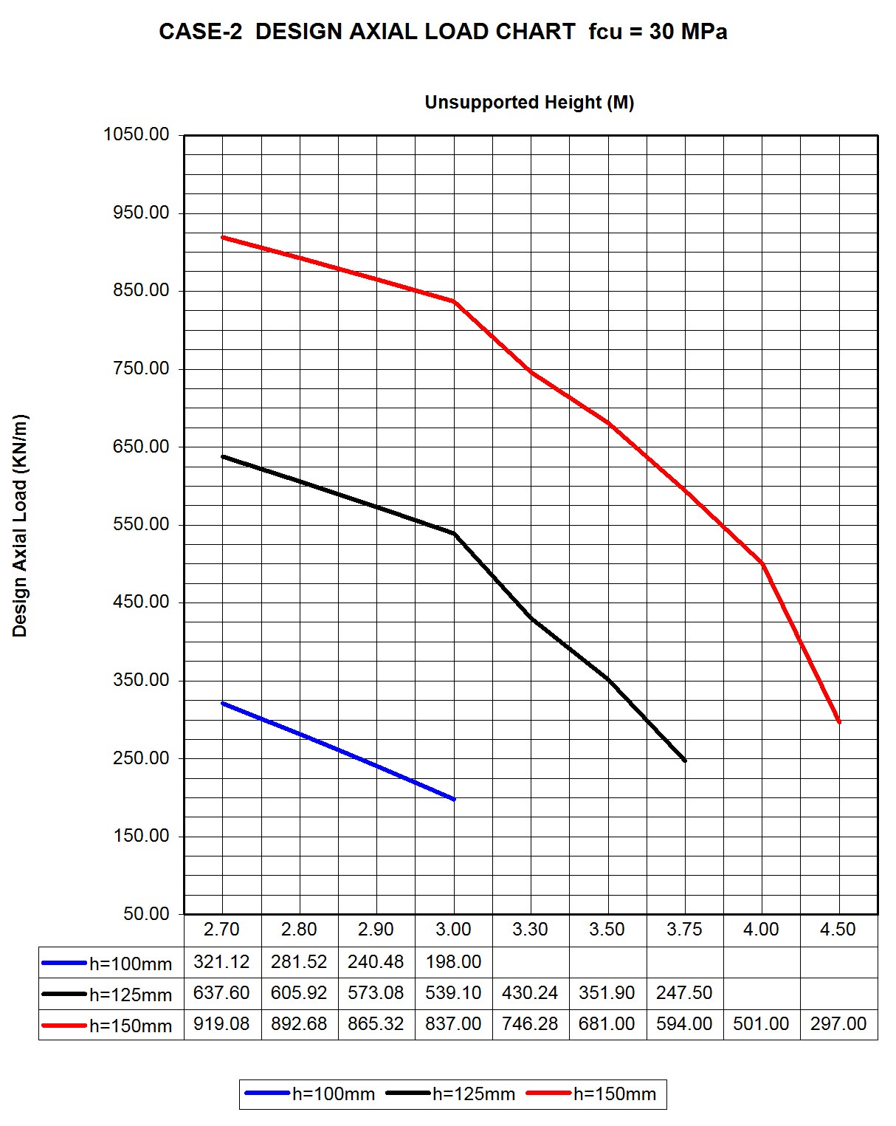

4.4 IS 456 : 2000 Parameter

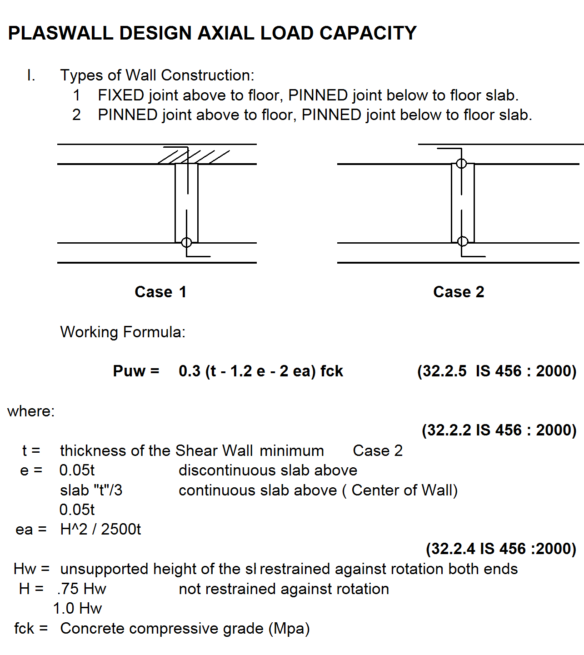

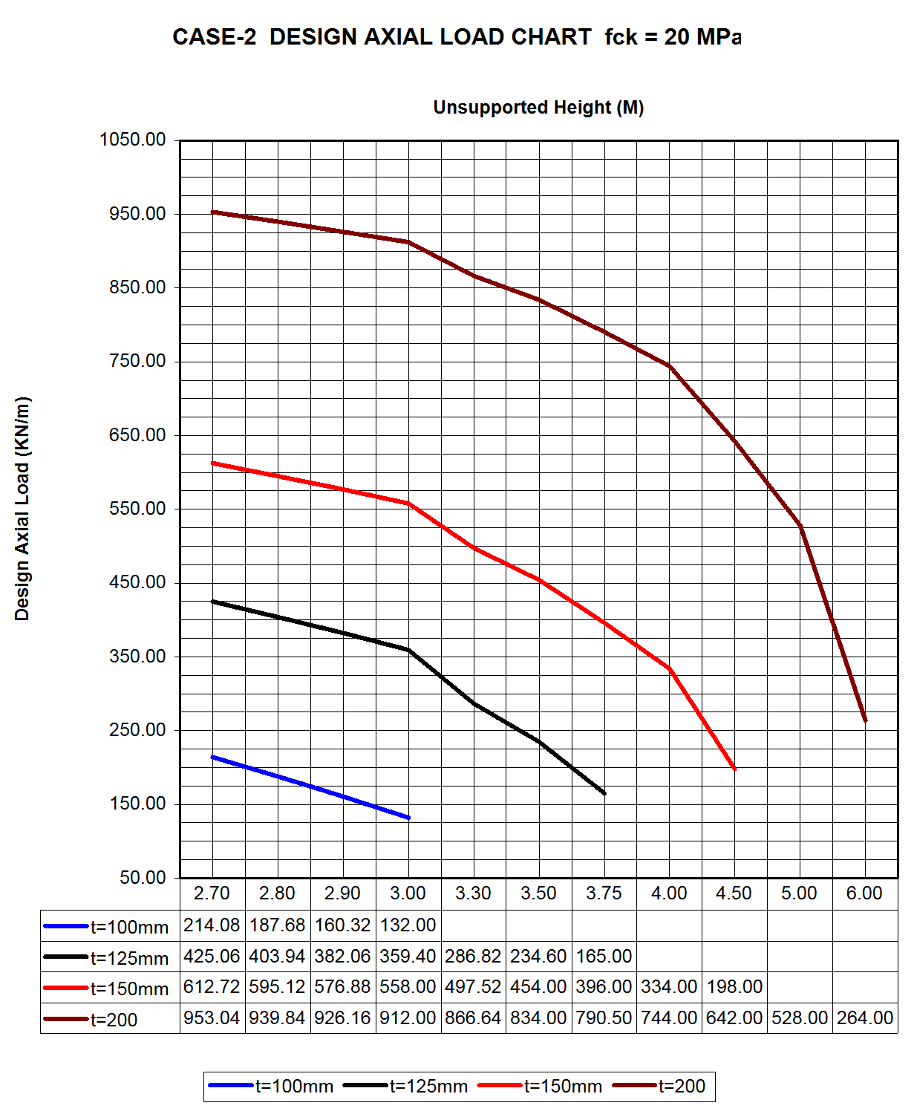

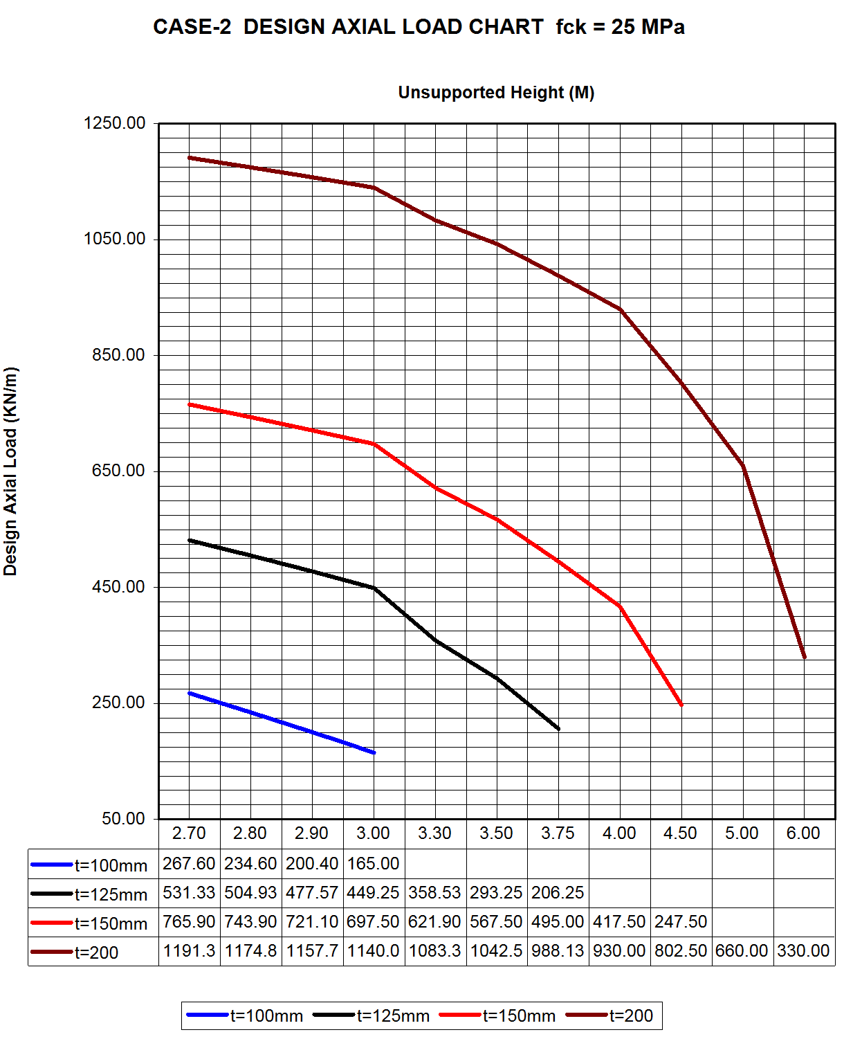

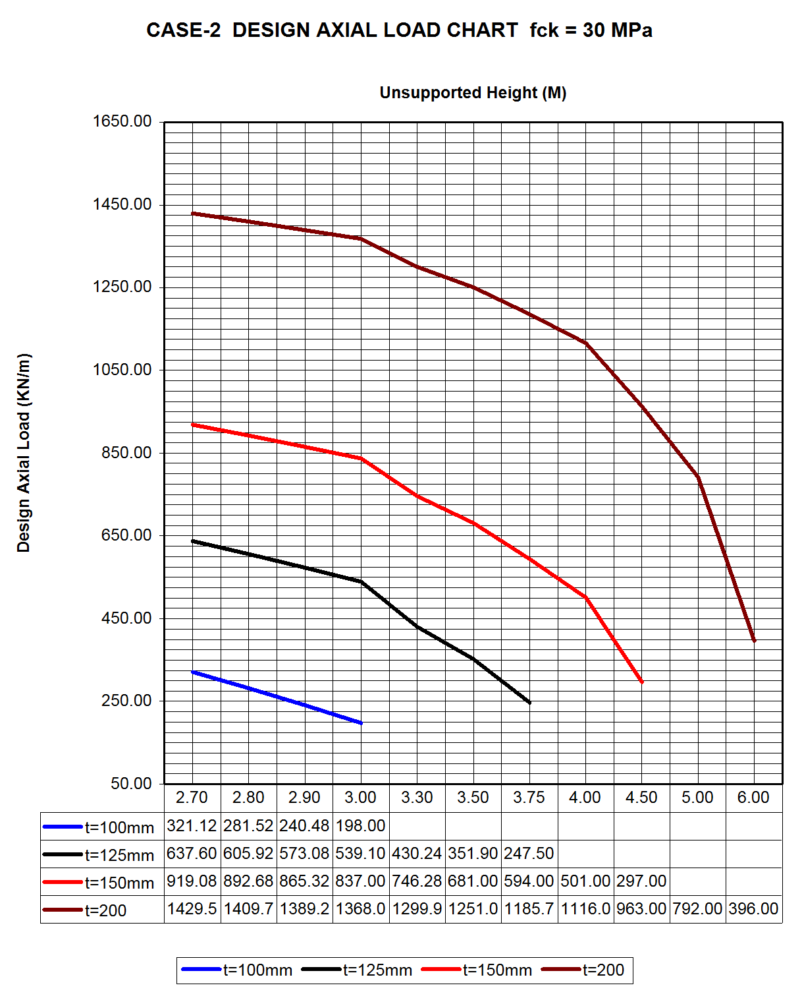

5 LATERAL LOAD CAPACITY

5.1 Lateral Load Capacity - NSCP 2001
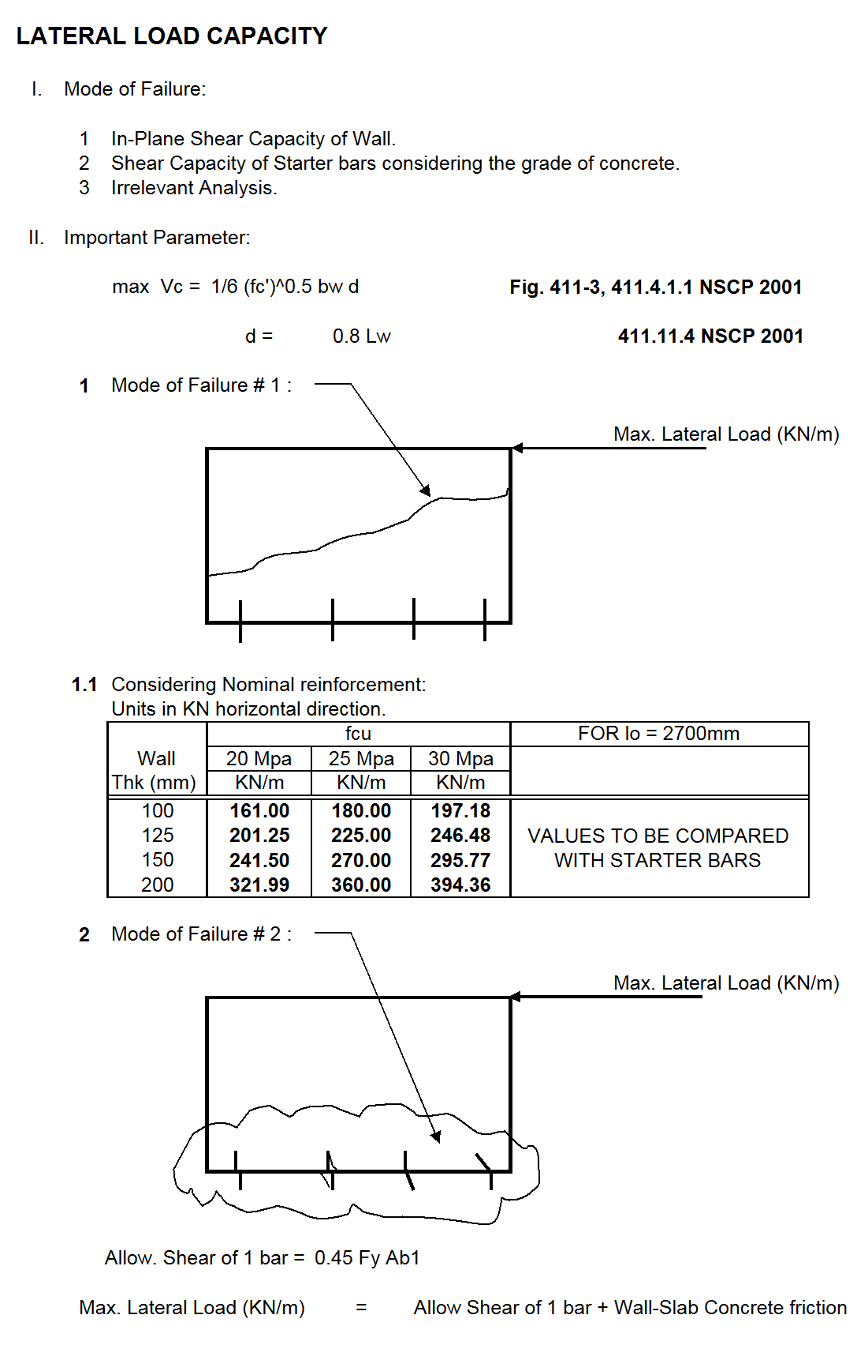

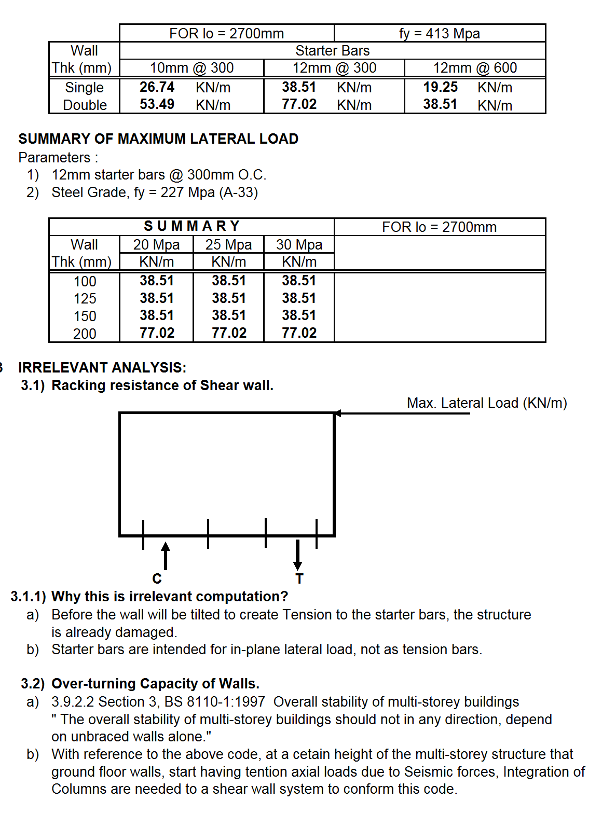

5.2 Lateral Load Capacity – ACI 318M:2005

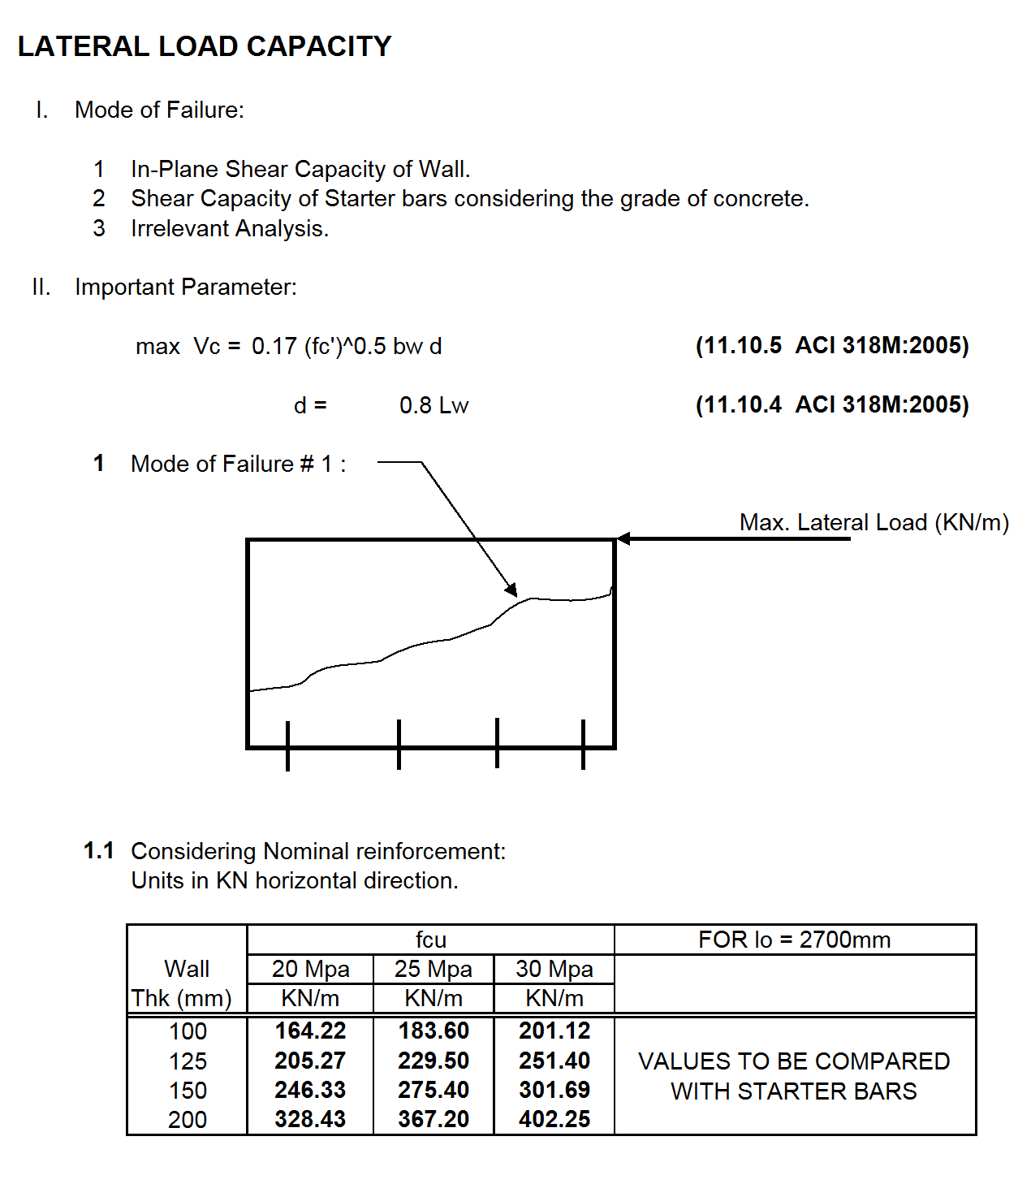

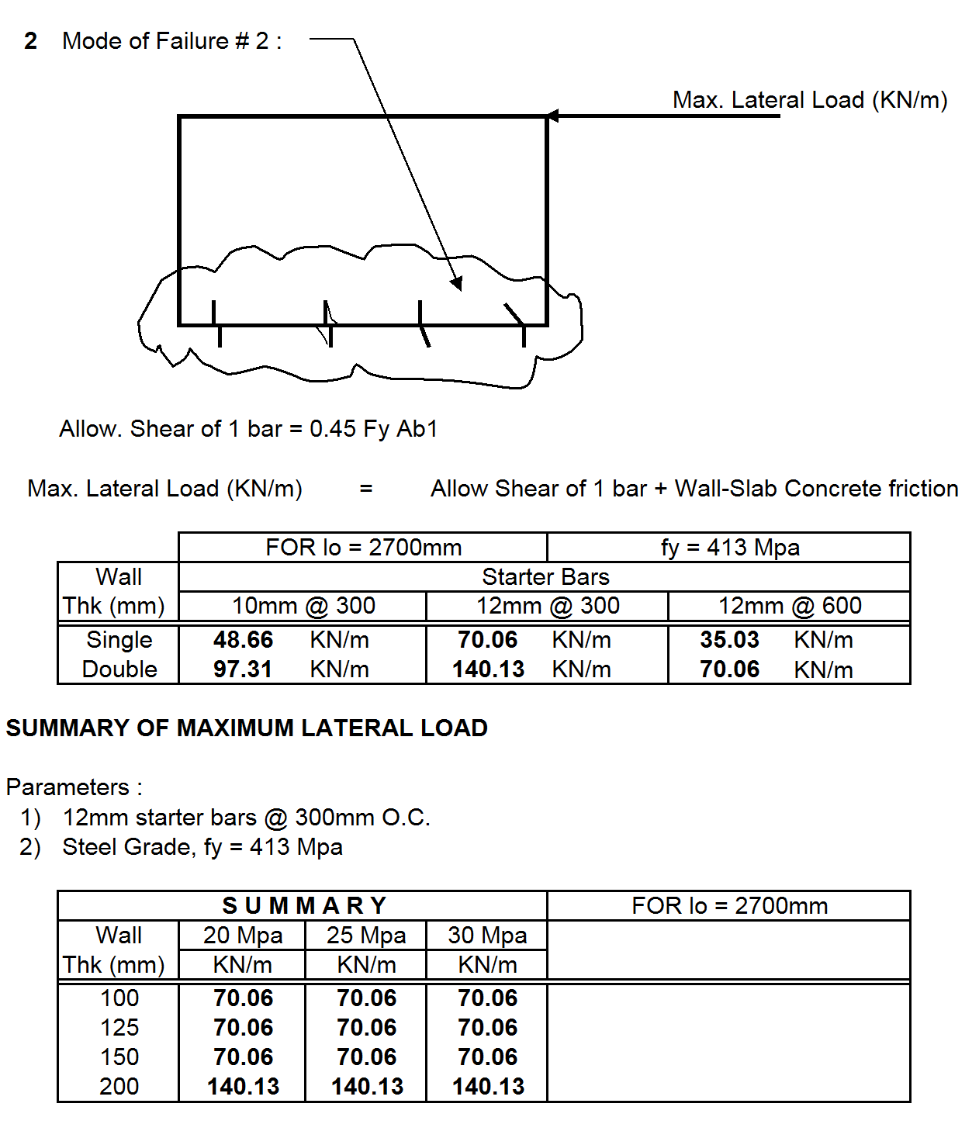

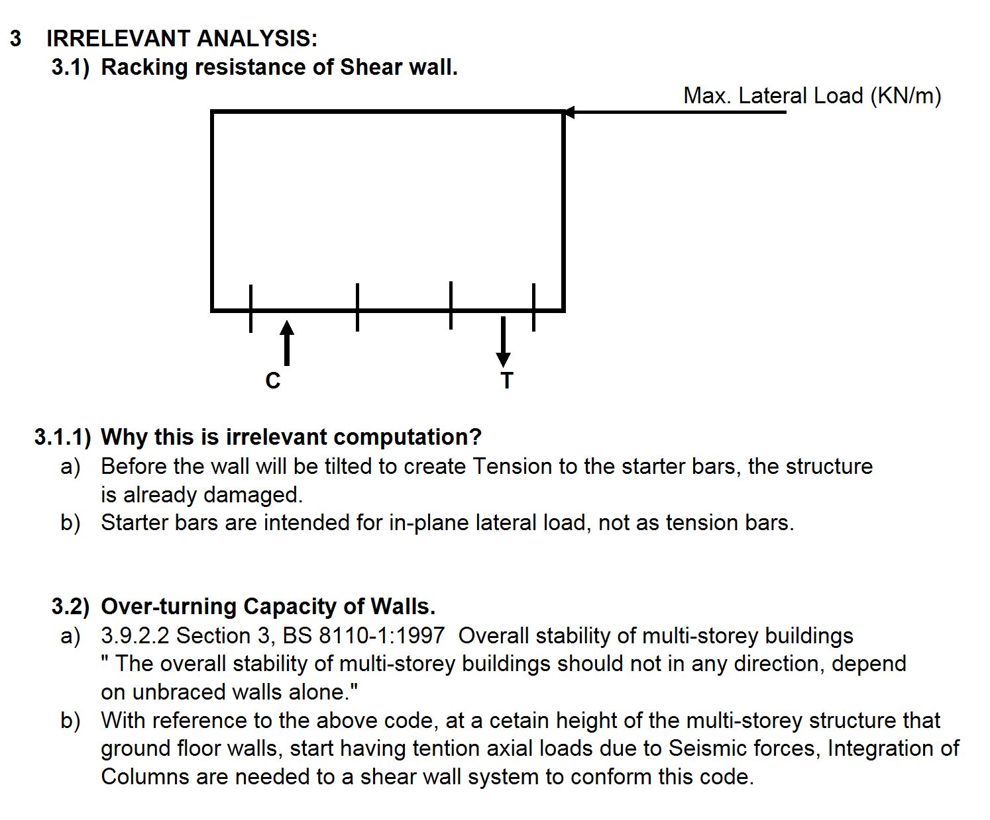

5.3 Lateral Load as per BS 8110-2:2005
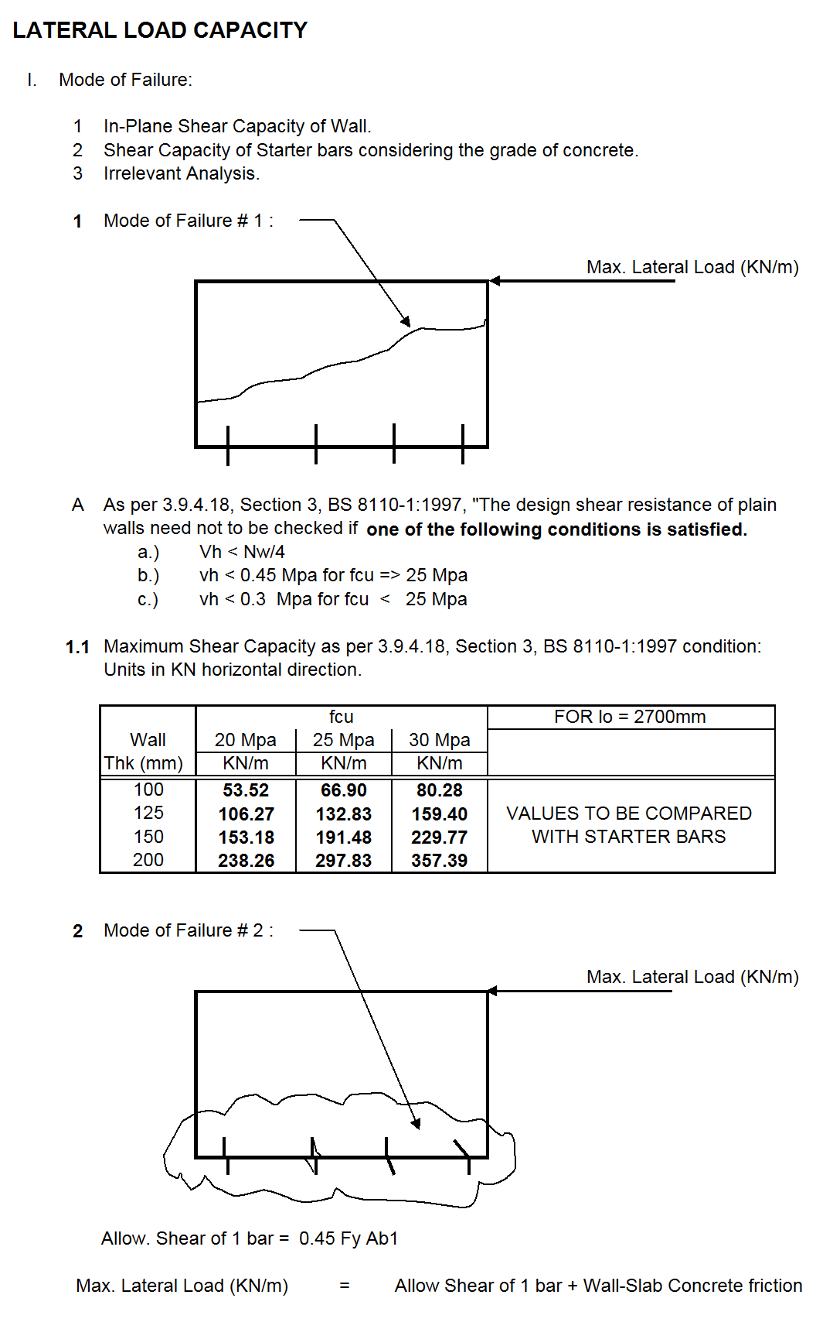

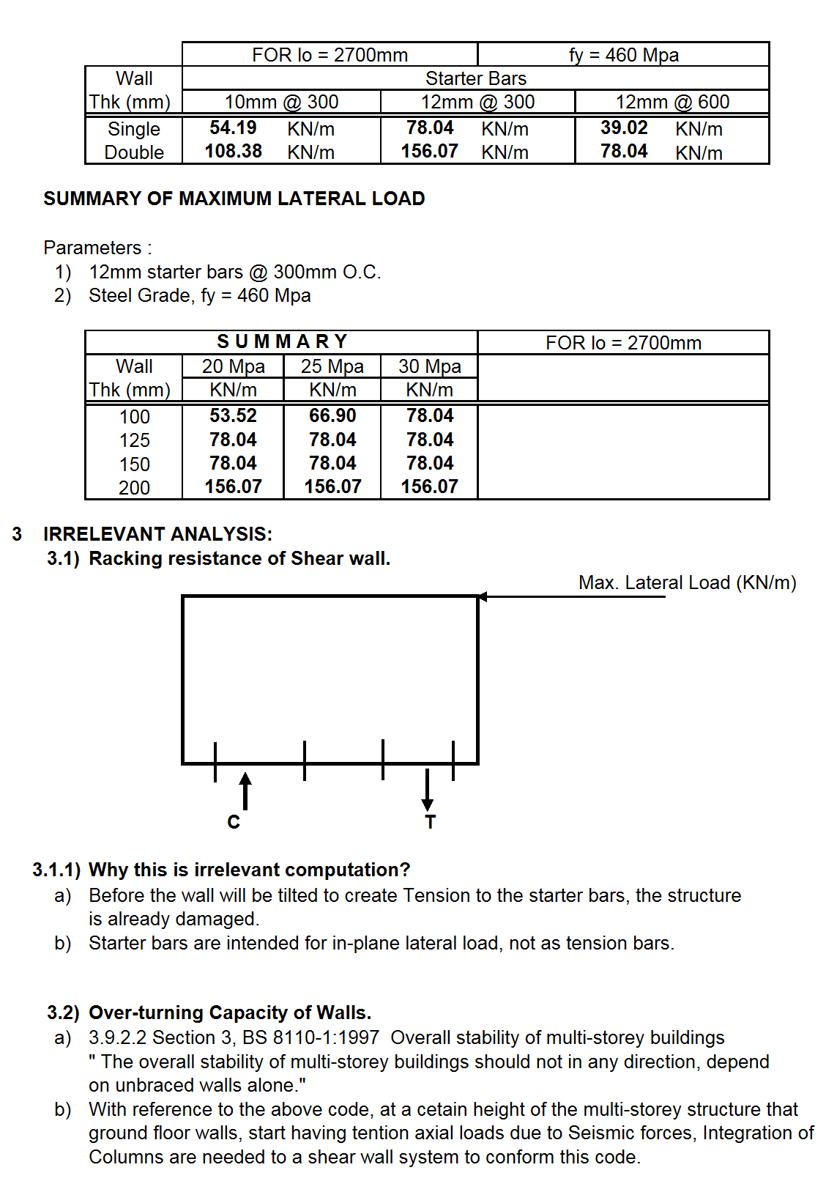

5.4 Lateral Load as per NSCP 2001
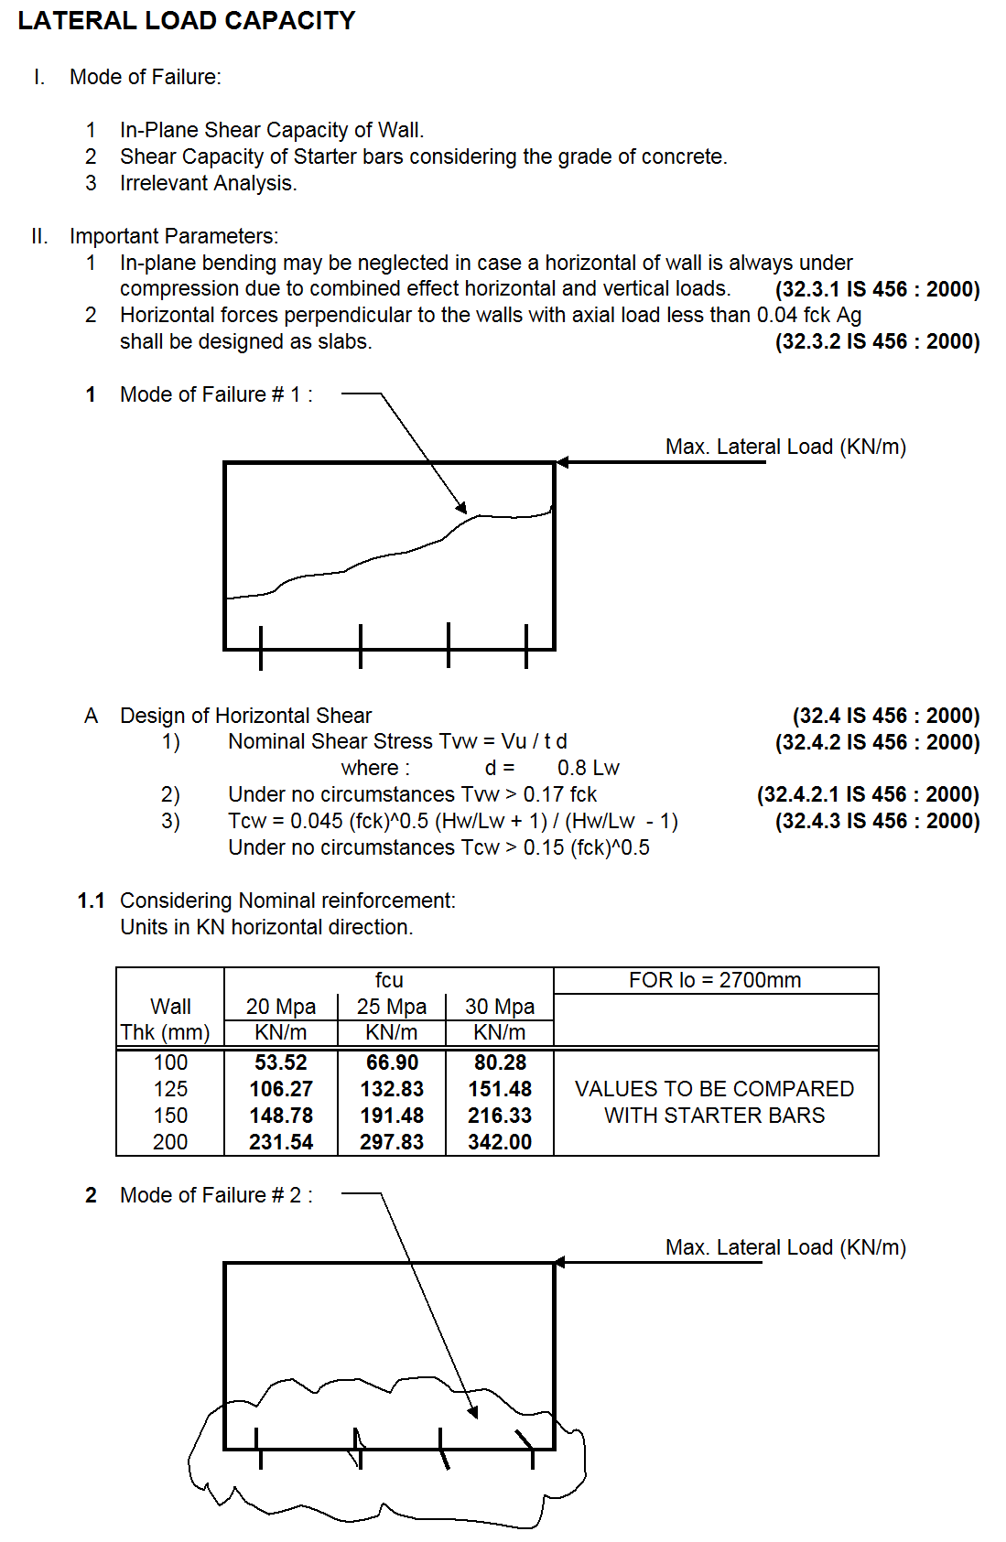

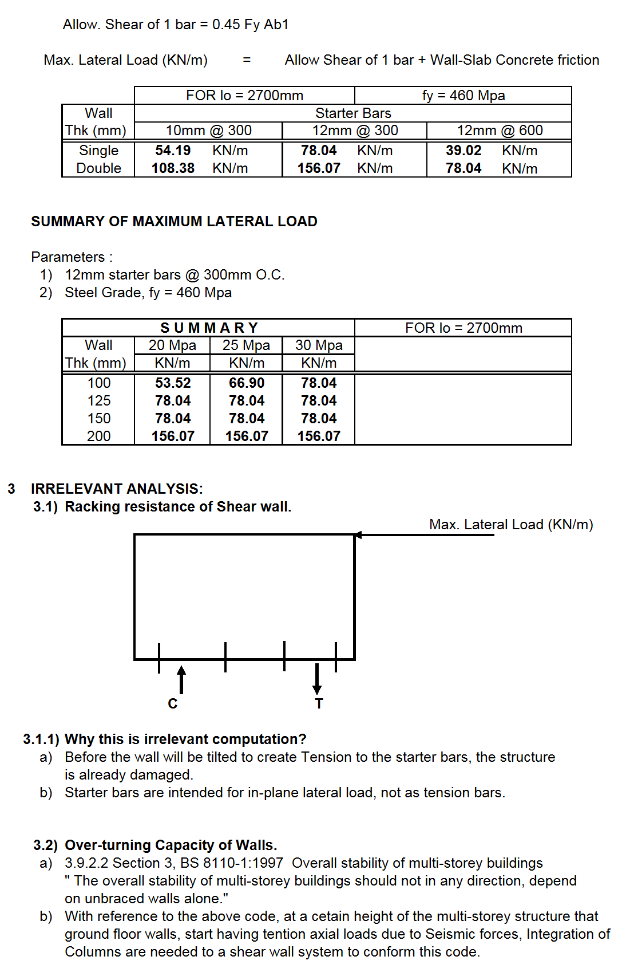

6 LATERAL LOAD ANALYSIS

